PV AND PVC

Persistent Volume Claims (PVCs) are used to request storage resources from a Persistent Volume (PV). Here's a step-by-step guide on how to create a PVC and assign it to pods:
- A PersistentVolume (PV) is a piece of storage in the cluster.
It is created by an administrator or by a StorageClass (dynamic provisioning).
- A PersistentVolumeClaim (PVC) is a request for storage from a user or application.

Step 1: Create a Persistent Volume (PV)
Before creating a PVC, you need to have a Persistent Volume available. Here's an example of a simple PV configuration:
apiVersion: v1
kind: PersistentVolume
metadata:
name: my-pv
spec:
capacity:
storage: 1Gi
accessModes:
- ReadWriteOnce
hostPath:
path: "/mnt/data"
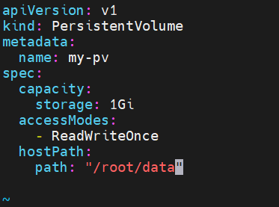
Save this configuration to a file, for example, pv.yaml, and apply it using:
kubectl apply -f pv.yaml

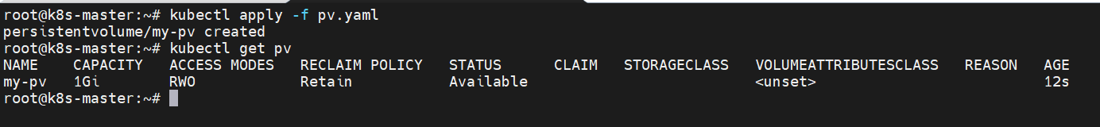

Step 2: Create a Persistent Volume Claim (PVC)
Now, you can create a PVC that will request storage from the PV:
apiVersion: v1
kind: PersistentVolumeClaim
metadata:
name: my-pvc
spec:
accessModes:
- ReadWriteOnce
resources:
requests:
storage: 1Gi
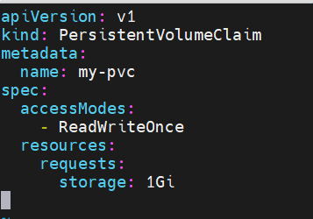
Save this configuration to a file, for example, pvc.yaml, and apply it using:
kubectl apply -f pvc.yaml

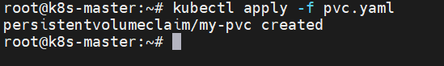

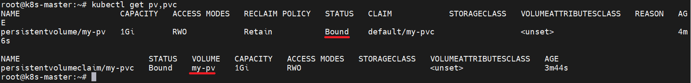

Step 3: Create a Pod using the PVC
Now, you can create a pod that uses the PVC by referencing the PVC in the volumes section and mounting the volume in the containers section:

apiVersion: v1
kind: Pod
metadata:
name: my-pod
spec:
containers:
- name: my-container
image: nginx
volumeMounts:
- name: storage
mountPath: "/usr/share/nginx/html"
volumes:
- name: storage
persistentVolumeClaim:
claimName: my-pvc

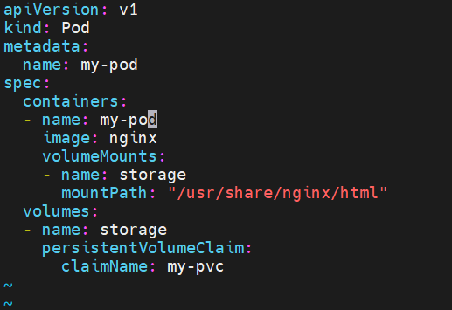
Save this configuration to a file, for example, pod.yaml, and apply it using:
kubectl apply -f pod.yaml

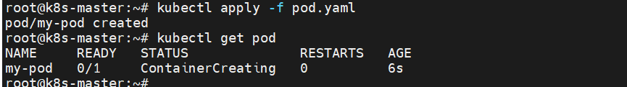

This example assumes you have a simple NGINX container using the storage provided by the PVC. Adjust the configurations based on your specific use case and requirements.

===========================================================================

Introduction
Managing storage is a distinct problem from managing compute instances. The PersistentVolume subsystem provides an API for users and administrators that abstracts details of how storage is provided from how it is consumed. To do this, we introduce two new API resources: PersistentVolume and PersistentVolumeClaim.

A PersistentVolume
- (PV) is a piece of storage in the cluster that has been provisioned by an administrator or dynamically provisioned using Storage Classes. It is a resource in the cluster just like a node is a cluster resource.
- PVs are volume plugins like Volumes, but have a lifecycle independent of any individual Pod that uses the PV. This API object captures the details of the implementation of the storage, be that NFS, iSCSI, or a cloud-provider-specific storage system.

A PersistentVolumeClaim
- (PVC) is a request for storage by a user. It is similar to a Pod. Pods consume node resources and PVCs consume PV resources. Pods can request specific levels of resources (CPU and Memory).
- Claims can request specific size and access modes (e.g., they can be mounted ReadWriteOnce, ReadOnlyMany, ReadWriteMany, or ReadWriteOncePod, see AccessModes).

There are two ways PVs may be provisioned: statically or dynamically.

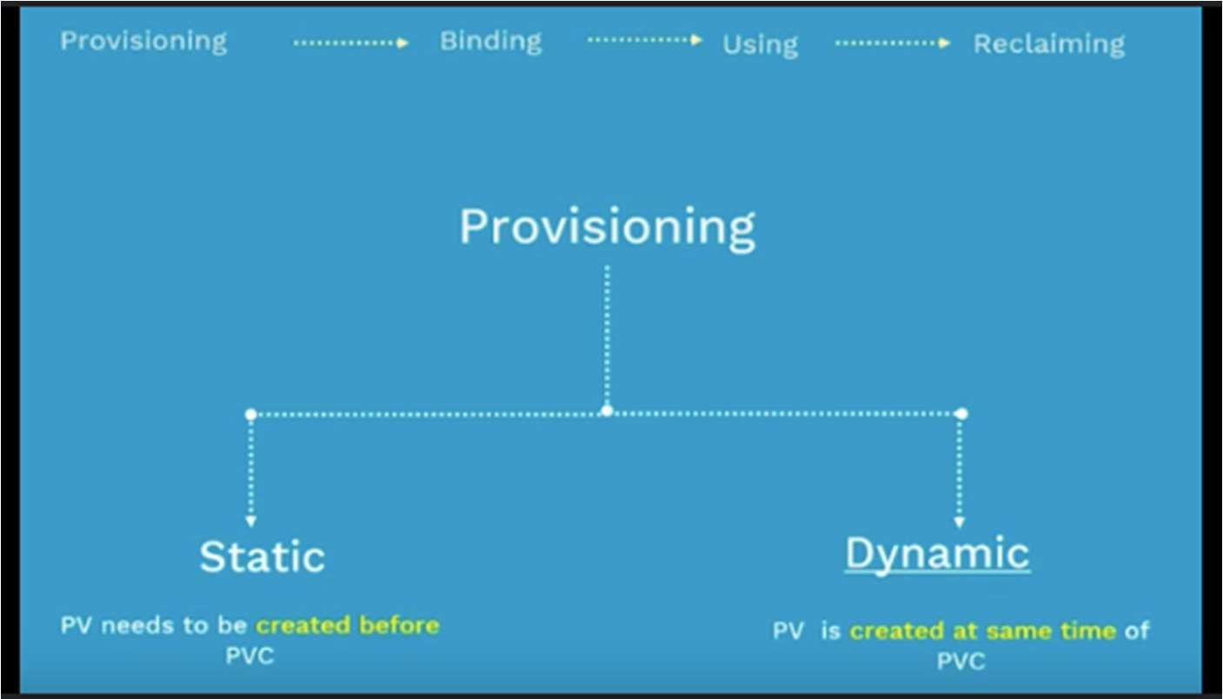

Persistent Volumes (PV)
Definition: Persistent Volumes are storage resources provisioned in a Kubernetes cluster, managed by the cluster administrator. They provide an abstraction layer over physical storage devices, allowing users to access storage without needing to know the underlying infrastructure details.

Available Options:
- Capacity: Specifies the size of the volume.
- Access Modes: Defines how the volume can be accessed. Below are the available options.
- ReadWriteOnce: Can be mounted as read-write by a single node.
- ReadOnlyMany: Can be mounted as read-only by multiple nodes.
- ReadWriteMany: Can be mounted as read-write by multiple nodes.
- Storage Class Name: Associates the PV with a specific Storage Class.
- Volume Mode: Determines whether the volume is mounted as a filesystem or block device.

- Persistent Volume Reclaim Policy: Determines what happens to the PV’s resources when released.
- Mount Options: Additional options to be passed to the mount command.

Manual PV Creation
apiVersion: v1
kind: PersistentVolume metadata:
name: example-pv spec:
capacity:
storage: 10Gi accessModes:
- ReadWriteOnce storageClassName: manual
persistentVolumeReclaimPolicy: Retain

Persistent Volume Claims (PVC)
Definition: Persistent Volume Claims are requests for storage made by users or applications running in the cluster. They allow users to consume storage without needing to know the specifics of how it is provisioned.

Available Options:
- Capacity: Specifies the minimum size of the volume.
- Access Modes: Requests the required access mode.

- ReadWriteOnce: Can be mounted as read-write by a single node.
- ReadOnlyMany: Can be mounted as read-only by multiple nodes.
- ReadWriteMany: Can be mounted as read-write by multiple nodes.
- Storage Class Name: Requests a specific Storage Class.
- Volume Mode: Determines whether the volume is mounted as a filesystem or block device. Filesystem is the default mode used when volumeMode parameter is omitted.

Dynamic PV Provisioning with SC
apiVersion: v1
kind: PersistentVolumeClaim metadata:
name: example-pvc spec:
accessModes:
- ReadWriteOnce resources:
requests:
storage: 5Gi storageClassName: standard volumeMode: Filesystem

Storage Classes (SC)
Definition: Storage Classes define the types of storage available in the cluster and how they are provisioned. They enable dynamic provisioning of PVs based on predefined templates or policies.

Available Options:

  - Provisioner: Specifies the type of volume plugin used for provisioning.
  - Parameters: Custom parameters for the provisioner.
  - Reclaim Policy: Determines what happens to the PV’s resources when released. Below are the available options.

- Retain: When a PersistentVolumeClaim with the Retain policy is deleted, the associated PersistentVolume is released but retains data. Administrators manually reclaim the volume by deleting it and its associated data.
- Delete: For volume plugins that support the Delete reclaim policy, deletion removes both the PersistentVolume object from Kubernetes, as well as the associated storage asset in the external infrastructure.
- Recycle: Recycle reclaim policy performs a basic scrub (rm -rf
/thevolume/*) on the volume and makes it available again for a new claim. (The Recycle reclaim policy is deprecated. Instead, the recommended approach is to use dynamic provisioning.)

  - Volume Binding Mode: Determines when a PV is bound to a PVC. Below are the available options.

- Immediate mode indicates that volume binding and dynamic provisioning occurs once the PersistentVolumeClaim is created.
- WaitForFirstConsumer mode which will delay the binding and provisioning of a PersistentVolume until a Pod using the PersistentVolumeClaim is created.

Creating a Storage Class
apiVersion: storage.k8s.io/v1 kind: StorageClass
metadata:
name: standard
provisioner: kubernetes.io/aws-ebs parameters:
type: gp2 reclaimPolicy: Delete
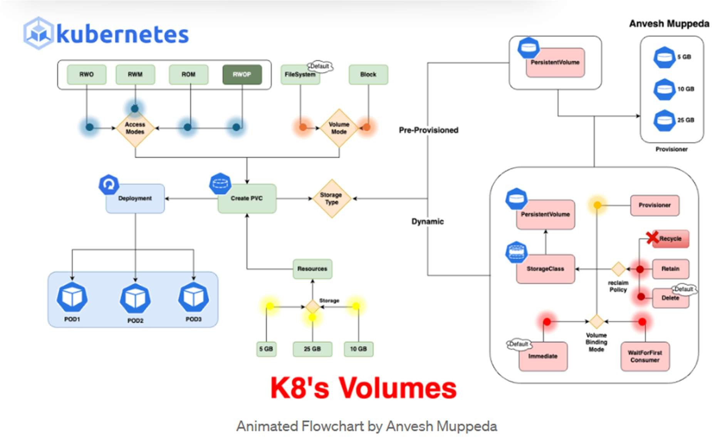
volumeBindingMode: Immediate

